PRESS RELEASE

Local Society Hosts “Super Bowl of Gem Shows” at Ventura County Fairgrounds

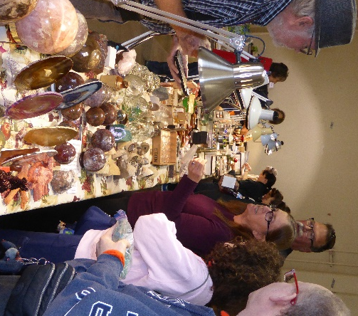
The Ventura Gem & Mineral Society (VGMS) is pleased to host “Seaside Gems at Ventura,” the National Gem, Mineral, Fossil & Jewelry Show taking place May 24-26 (10am–5pm, Fri. & Sat.; 10am–4pm, Sun.) at the Ventura County Fairgrounds (10 W. Harbor Blvd., Ventura). The show is open to the public and features family-friendly events and exhibits. Admission is $8, with children under 13 free with a paid adult. (Note: the Fairgrounds also charges a parking fee.)

VGMS is celebrating its 80th anniversary and was selected from 600 similar nonprofit educational societies to host a truly big national event, namely, the Annual Show & Convention of the American Federation of Mineralogical Societies. They hope to welcome over 3,000 “rockhounds” as they converge on the Ventura County Fairgrounds for what’s described as “the Super Bowl of gem shows.”
This year’s “Super Bowl” organizers invite the general public to enjoy educational displays, dealers and demonstrators, speakers, silent auctions, raffles, and kids activities. For instance, a beautiful gold specimen will be one of the featured displays. Discovered by a young girl in Placer County in 1871, the California Golden Bear nugget is normally housed at the Los Angeles County Museum of Natural History but will be on temporary display at the show alongside samples of our ultra-rare State Gemstone, sapphire-blue benitoite.
Nearly 100 additional educational exhibits are expected of hand-crafted jewelry and carvings, gemstones and crystals, minerals, fossils, and fluorescent rocks that glow in the dark. These exhibits have been assembled from private collections and crafters throughout California and the U.S. and should be exceptional, given that over half will be entered into refereed competition vying for trophies.
Displays will be augmented by demonstrators illustrating how rough stones are crafted into gleaming gems. Watch lapidary artists at work and question them for tips to try yourself. They’ll demo lapidary arts like gemstone grinding, carving and polishing; jewelry-making techniques; bead stringing; silver work, and fossil prep.
Kids are sure to enjoy the Kids Booth. A variety of interactive activities are free or priced to match a child’s budget. These include a Dino Dig; coloring activities; a spinning wheel where every spin wins a prize; grab bags filled with rocks, minerals, and fossils; “create-your-own-collection” boxes; and a sand-sifting activity. A prospecting club—Valley Prospectors of San Bernardino—will show kids and adults alike how to pan for gold just like a Forty-Niner. Teachers will find free teacher resources, including rock samples and packets of educational materials at the show Welcome Booth.
To get a jump on Christmas shopping, 50+ vendors are expected, selling all manner of rock-related materials: rough agate, jasper, marble, and more to cut, carve, and polish; gemstone rough (amethyst, opal, emerald, sapphire, ruby, tourmaline, jade) to cab or to facet; cut and polished gemstones ready to be mounted into jewelry settings; lapidary and jewelry tools and equipment; minerals and gemstone crystals and meteorites for collectors, whether beginners or advanced; fossils and petrified wood from around the world; gem-, mineral-, and fossil-related publications; beads of all sorts; stone carvings, spheres, and other sculpted works for home decor; and fine custom jewelry ready to wear.
In addition to the professional vendors, enjoy hourly silent auctions throughout the show for lapidary rocks and gemstones, minerals, geodes, petrified wood, and fossils. And don’t miss the raffle! Those purchasing winning tickets will take home great prizes that include high quality jewelry; mineral and fossil specimens; and more—including a one hundred dollar bill.
A Speakers Series features nontechnical lectures with talks on such topics as meteorites, amber, an Australian gold mine, the geology of the Channel Islands off-shore from Ventura, and beautifully banded Condor Agates from Patagonia by the man who introduced them into the U.S. market.
VGMS and the American Federation of Mineralogical Societies are dedicated to encouraging interest in geology, mineralogy, paleontology, the lapidary and jewelry arts through education, activities, and exhibitions, such as this nationwide show, which circulates around the US and comes to California only once every seven years. AFMS is composed of local societies and clubs from throughout the US. AFMS and its affiliated societies are 501(c)3 nonprofit, educational organizations. Proceeds from their shows go toward educational endeavors, such as scholarship funds for undergraduate and graduate college students and a free badge program for children. During an Awards Banquet Saturday night, not only will trophies be given for best competitive displays, but also scholarships will be awarded to college students working toward degrees in the earth sciences.
For further info, email info@vgms.org or call 805-312-8467. Visit the show website at 2024CFMS-AFMS.com and the local Ventura society website at vgms.org.

